**Homework 1**

1. **What are 3 conclusions we can make about Kickstarter campaigns given the data?**

These conclusions focus on insights into Kickstarter’s success rate and what makes these subpopulations of successes more possible. Figures are approximately reported.

1. Kickstarter may not be as helpful as the success rate might indicate

While about 53% of all completed campaigns are successful, the mean goal is projected for $69,000 while the pledge is only $11,000.

Those successful in meeting goals averaged a surplus of about $9,000. Those who failed, even excluding those who did not receive any pledges, were met with an average minus of $48,000.

1. Number of backers is more important than getting “jackpot” donators

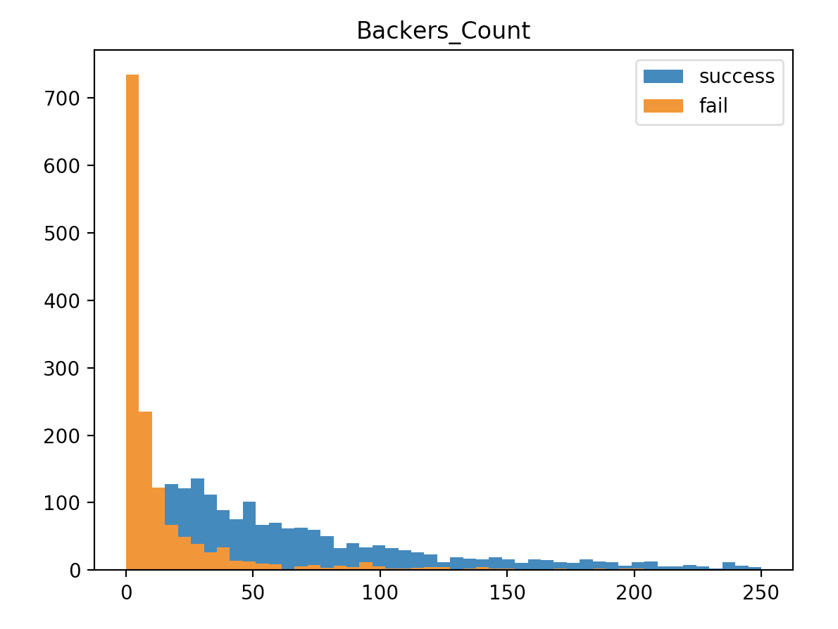Looking at successful versus not successful campaigns as separate data tables, we can see that the average pledge for successful campaigns is actual significantly lower than for cancelled vs failed one- with a difference of $97 to $137. Even excluding the 404 campaigns without a single donator in the not successful subset, the difference remains at $97 to $139.

The average number of backers for successful and not successful campaigns shows the difference clear enough, at approximately 194 to 20 backers, respectively. A histogram gives a clear visual representation.

1. Having Staff approval in the “staff_pick” feature is significant, though not necessarily a good indicator

Of 556 staff picks, 87% were successful. Of the other 3508, only 48% were successful. Given the huge difference, even a non-parametric difference of proportions test (chi-squared) rejects the idea that the proportions are equal with p-value of 2.2e-16. We can assume that either the staff pick is directly affecting the success rates, or they are effective in predicting a success.

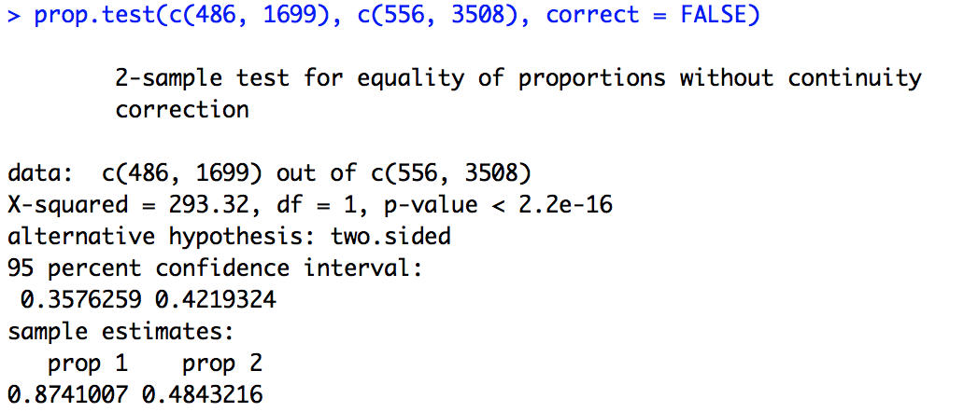

1. **Limitations of this Dataset**

Going deeper with the analysis on success versus failure from Question 1, we are unable to tell whether the staff’s picks are creating a bias influence on a campaign’s success or whether they are predicting the success.

For example, since Kickstarter can advertise its success as a reason for people to join, the most obvious choice would be for them to push for success in their campaigning members. Since they are directly involved in the process, the outcomes for much of the data is probably influenced by Kickstarter itself.

1. **Other Potential Tables**

Another valuable insight might be looking at a table of the time versus success of different campaigns. By looking at the trend, we can see whether Kickstarter is becoming more or less successful with their clients.

Going further with this, we can group the number of clients by starting or ending dates and see through visualizations whether the number of clients Kickstarter is working with has an effect on the success rate. For example, if the number of clients is not being controlled well, or if Kickstarter is being greedy with accepting projects, their performance might deteriorate. At the same time, as popularity grows, donations and backers might increase as well given that Kickstarter’s name would become more recognizable as a brand name logo.